A

REPORT

ON

INDUSTRIAL TRAINING ON

“Web Application Development”

Taken at

VeroLie Pvt Ltd
In partial fulfillment of the requirement for the award of degree of
Bachelor of Technology
In
Information Technology


(Session 2025-26)

Duration: From 19/05/2025 to 20/07/2025

Submitted to: Submitted by:
Dr. Smita Agarwal Utkarsh Singh
Mr. Piyush Gautam 22EJCIT177
VII Semester (C)

Department of Information Technology
Jaipur Engineering College & Research Centre, Jaipur
Rajasthan Technical, University
NOVEMBER-2025

Internship Certificate


CERTIFICATE

This is to certify that the report of the training submitted is the outcome of the practical training done at “VeroLie Pvt Ltd” in “Web Application Development” is carried out by Utkarsh Singh bearing RTU Roll No.:22EJCIT177 under the guidance and supervision of “Mr. Vinod Sharma” for the award of Degree of Bachelor of Technology (B. Tech.) in Information Technology from Jaipur Engineering College & Research Centre, Jaipur (Raj.), India affiliated to Rajasthan Technical University, Kota during the academic year 2025-2026.

To the best of my knowledge the report
- Embodies the work of the candidate.
- Has duly been completed.
- Fulfills the requirement of the ordinance relating to the bachelor of technology degree of the Rajasthan technical University and
- Is up to the desired standard for the purpose of which is submitted.

_______________ |  | _______________
Dr. Smita Agarwal |  | Mr. Piyush Gautam
Head of Department |  | Assistant Prof. & PTS Coordinator
Information technology |  | Information Technology
JECRC, Jaipur |  | JECRC, Jaipur

DECLARATION

I hereby declare that the report entitled “INDUSTRIAL TRAINING ON WEB APPLICATION DEVELOPMENT” has been carried out and submitted by the undersigned to the Jaipur Engineering College & Research Centre, Jaipur (Rajasthan) in an original work, conducted under the guidance and supervision of Mr. Vinod Sharma of VeroLie Pvt. Ltd, Jaipur.
The empirical findings in this report are based on the data, which has been collected by me. I have not reproduced from any report of the University neither of this year nor of any previous year.
I understand that any such reproducing from an original work by another is liable to be punished in a way the University authorities’ deed fit.

Place: Jaipur Utkarsh Singh
Date: 07-11-2025 22ECIT177

PREFACE

Bachelor of Technology in Information Technology is the Rajasthan Technical University course (Approved by AICTE) having duration of 4 years. As a prerequisite of the syllabus every student on this course has to take professional training from any Industry related to the stream for 60 days in order to complete his/her studies successfully. And it is required to submit the project report on the completion of it.
The main objective of this training is to create awareness regarding the application of theories in the practical world of Information Technology and to give a practical exposure of the real world to the student.
I, therefore, submit this project report of this training, which was undertaken at VeroLie Pvt. Ltd, Jaipur. It was a good experience to have training in a reputed organization, where I had the opportunity to work on Full-Stack Web Development with modern technologies. I feel great pleasure in presenting this project report on the Inventory Management System, which was developed as part of my training. The report has been prepared on the basis of the study and practical implementation carried out to design and develop a system that overcomes the limitations of traditional inventory management practices.

ACKNOWLEDGEMENT

“Any serious and lasting achievement or success, one can never achieve without the help, guidance and co-operation of so many people involved in the work.
It is my pleasant duty to express my profound gratitude and extreme regards and thanks to Mr. Arpit Agarwal and Dr. V.K. Chandna who gave me an opportunity to take professional training in VeroLie Pvt. Ltd, Jaipur.
I am indebted towards Mr. Vinod Sharma who has allotted this project and his precious time and advice during the training period, which is imminent to the report.
I would like to express deep gratitude to Dr Smita Agrawal, Head of Department (Information Technology), Jaipur Engineering College & Research Centre, Jaipur (Rajasthan) without whose permission the training would not be possible. I would also like to thank Mr. Piyush Gautam, Training & Placement Officer and PTS Coordinator, Department of Information Technology JECRC, Jaipur who recommended me for this training.
Last but not the least, I am grateful to my beloved parents whose blessings and inspirations are always with me. I am heartily thankful to those people who are involved directly or indirectly in this project for encouraging me whenever I needed their help in spite of their busy schedule.

Utkarsh Singh (22EJCIT177)

COMPANY PROFILE

VeroLie Pvt. Ltd. is a Jaipur-based, full-service clothing manufacturing company specializing in sportswear and fashion apparel. Operating from 1st Floor, Podar Circle, G1-41, Sanganer, Sitapura, Jaipur, Rajasthan – 302022, we design, manufacture, and deliver high-quality, fashionable, and durable apparel for both domestic and international markets.
With a strong emphasis on precision, design, and sustainability, VeroLie offers end-to-end apparel solutions—from fabric sourcing and production to packaging and global distribution. Our expertise spans sportswear, casual wear, uniforms, and customized apparel, ensuring that every product blends performance, comfort, and style.
The company’s identity is captured by the tagline “Wear Your Dream,” reflecting our vision of combining creativity with cutting-edge processes. Beyond traditional manufacturing, VeroLie integrates technology-driven systems for inventory management, production tracking, and order management, ensuring efficiency, transparency, and timely delivery across the supply chain.
In addition, VeroLie has developed custom web applications for internal use and client support, enabling seamless order placement, production monitoring, and real-time reporting. These digital tools not only streamline operations but also empower clients with visibility and control over their apparel requirements.
As an MSE (Micro & Small Enterprise) based out of India, we merge textile craftsmanship with modern technology—leveraging advanced machinery, digital design tools, and smart workflow automation to meet global standards in quality and scalability.
Focused on sustainability, innovation, and customer trust, VeroLie adopts eco-conscious practices while delivering tailor-made solutions for brands, retailers, and businesses. By combining fashion expertise with technology, we help our clients stay competitive in a fast-moving market, offering apparel that performs, inspires, and endures.

Chapter Index

S.  No. | TITLE | PAGE NO.
 | Training Certificate | i
 | Certificate | ii
 | Declaration | iii
 | Preface | iv
 | Acknowledgement | v
 | Company Profile | vi
1. | Introduction
 | 1.1 About | 1
 | 1.2 Purpose | 2
 | 1.3 Scope | 3
 | 1.4 Features | 3
2. | Key Technologies | 5
 | 2.1 Front End Dev | 5
 | 2.2 Back End Dev | 6

3. | Overview of Tools Used
 | 3.1 HTML | 8
 | 3.2 CSS | 8
 | 3.3 JAVASCRIPT | 8
 | 3.4 ReactJS | 9
 | 3.5 Express.js | 9
 | 3.6 MongoDB | 10
 | 3.7 Git & Github | 10
 | 3.8 Render & Vercel | 10
4. | Client–Server Architecture
 | 4.1 Introduction | 11
 | 4.2 Components of Client–Server Model | 11
 | 4.3 Client–Server Communication | 11
 | 4.4 REST APIs in Client–Server Architecture | 12
 | 4.5 Advantages of Client–Server Model | 13
5. | Node.js and Express
 | 5.1 Introduction | 14
 | 5.2 What is Node.js? | 14
 | 5.3 What is Express.js? | 15
 | 5.4 How Node.js and Express Work Together | 16
 | 5.5 Example in Inventory Management System | 16
 | 5.6 Advantages in Real-World Applications | 17
6. | Project Description | 18
 | Conclusion | 27
 | Future Scope | 28
 | References | 29

Figure Index

S.  No. | Title | Page no.
1. | Sample Output for JS | 9
2. | Sample Input for MongoDB | 10
3. | Client-Server Architecture | 12
4. | Node.js Architecture | 15
5. | Screenshots of Project | 21-27

CHAPTER 1
INTRODUCTION
Inventory Management refers to the process of ordering, storing, tracking, and controlling the stock of goods within an organization. It ensures that the right quantity of products is available at the right time, reducing wastage and optimizing resources.

  - ABOUT
Proper inventory management is essential for businesses that handle raw materials, finished products, or any form of stock, as it directly impacts efficiency, profitability, and customer satisfaction.
The hierarchy of inventory management generally includes:
- Stock In : Recording all incoming goods and materials.
- Stock Out : Managing dispatch, sales, or usage of goods.
- Inventory Records: Maintaining up-to-date product details, quantities, and categories.
- Audit and Reporting: Tracking all activities for accountability and decision-making.
Traditionally, businesses used manual registers or spreadsheets for stock handling, but these methods are time-consuming, error-prone, and lack real-time updates. To overcome these limitations, digital inventory systems have been developed that leverage web technologies for automation, accuracy, and accessibility.
An Inventory Management System (IMS) integrates database technology, server-side logic, and client-side interfaces to deliver a complete solution. It allows administrators and staff to:
- Add and update product details such as category, size, and packaging.
- Record stock in (inset) and stock out (outset) transactions in real time.
- Generate reports and audit logs for monitoring activities.
- Securely authenticate users and assign role-based permissions.
By using modern frameworks like React.js, Node.js, Express.js, and MongoDB, IMS provides a responsive, secure, and scalable platform. It reduces manual effort, ensures accuracy, and helps organizations make informed decisions regarding stock handling and resource utilization.

PURPOSE
1.2.1 It streamlines stock handling
An Inventory Management System simplifies the process of tracking stock in (inset) and stock out (outset). Instead of using manual registers or spreadsheets, the system automates data entry, reduces errors, and provides real-time updates, ensuring that businesses always have accurate information about their inventory.
1.2.2 It improves operational efficiency
By automating routine inventory tasks, the system reduces the workload on staff and administrators. Features like product categorization, filtering, and search make it easier to access information quickly. This saves time and allows employees to focus on more strategic activities.
1.2.3 It ensures accountability through audit logs
The system records every action performed by users, such as adding stock, dispatching goods, or updating product details. These logs provide transparency and accountability, ensuring that every transaction can be traced back to a responsible person.
1.2.4 It enhances decision-making
With real-time data and reporting features, administrators can analyze stock levels, identify frequently used products, and forecast future requirements. This helps businesses avoid overstocking or understocking and ensures better resource management.
1.2.5 It provides secure role-based access
By implementing authentication mechanisms such as JWT and bcrypt, the system ensures that only authorized users can access or modify inventory records. Role-based access (Admin/Staff) prevents unauthorized actions and keeps sensitive data protected.
1.2.6 It supports scalability and growth
The system has been designed using scalable technologies like Node.js and MongoDB. This allows businesses to expand their operations, handle larger datasets, and integrate new features like multi-warehouse support or supplier management without major changes.

SCOPE
The Inventory Management System manages stock operations by recording all inset (stock in) and outset (stock out) activities.
It allows product categorization based on size, color, and packaging for easy tracking. The system provides role-based access for administrators and staff to ensure security. Real-time updates, filtering, and search improve operational efficiency. Audit logs and scalability make the system reliable for both small and large organizations.

  - FEATURES
1.4.1 Stock Management
The system handles both stock in (inset) and stock out (outset) transactions with real-time updates.
It prevents errors that often occur in manual tracking and ensures accurate stock levels are always maintained.
This feature helps organizations avoid overstocking or running out of essential items.
1.4.2 Product Categorization
Products can be classified by attributes such as category, size, color, and packaging.
This structured classification makes searching and filtering easier, especially in large inventories.
It also simplifies report generation and improves overall inventory organization.
1.4.3 Role-Based Authentication
The system provides secure login and role-based access using JWT and bcrypt.
Administrators can manage users and the entire system, while staff members are limited to operational tasks.
Administrators can view detailed reports of transactions, which help in decision-making.
This feature adds transparency, accountability, and long-term data reliability.
1.4.5 Supplier and Purchase Management
The system allows tracking of suppliers, purchase orders, and delivery schedules. It helps in maintaining supplier details, order histories, and payment statuses. This feature ensures timely procurement and reduces supply chain delays.

CHAPTER 2
KEY TECHNOLOGIES

The front end of the Inventory Management System has been implemented using ReactJS, a widely adopted JavaScript library for building interactive and component-based user interfaces. React promotes a modular design where UI elements are encapsulated into reusable components, ensuring consistency, scalability, and maintainability across the application. Each page such as InsetPage, OutsetPage, Inventory Dashboard, and Admin Panel is constructed with smaller components like navigation bars, tables, filters, and forms, which can be reused or extended as the system grows.

Front End Dev
Styling has been achieved through CSS modules and custom design tokens, ensuring a clean and consistent user experience. Tables for inventory records use filter and search components to improve usability, while modals handle record updates and confirmations without disrupting workflow. React’s state management ensures predictable rendering and quick updates whenever stock levels or user details change.
The frontend communicates with the backend using Axios, encapsulated in a custom axiosInstance with JWT-based authentication. This ensures secure communication with APIs and automatically attaches tokens for protected routes. Conditional rendering is used to provide role-based access, ensuring that only admins or authorized users can view or modify sensitive information.
The design emphasizes responsiveness, ensuring smooth operation across desktops, tablets, and mobile devices. Modern CSS practices and responsive grid layouts adapt to different screen sizes, making it easier for staff or administrators to access the system on the go. To enhance accessibility, components are designed with semantic HTML, proper labeling, and keyboard navigation support.
Performance optimization techniques include lazy loading of routes, minimizing API requests, and using memoization for heavy table operations. Debugging is supported by console logs and error boundaries, making frontend issues easier to trace. With this structure, the frontend of the Inventory Management System provides an efficient, accessible, and user-friendly interface that simplifies inventory tracking and management tasks.
To further enhance maintainability, the frontend follows a clear folder structure separating pages, components, context, hooks, and utility functions. This ensures that each feature remains isolated and easy to update as the system grows. Reusable UI components such as buttons, inputs, dropdown selectors, and modal prompts are generalized to support multiple workflows including inbound, outbound, and admin operations.
- The component-driven structure ensures that UI updates remain isolated, reducing the chances of regressions when new features are added.
- Custom hooks are used for handling frequently repeated logic such as fetching data, managing forms, or handling authentication state.
- Client-side caching reduces unnecessary re-fetching of static data like product categories or user roles.
- Pagination and debounced search improve performance and make large inventory lists easier to navigate.
React Context is used for managing authentication state globally, which avoids prop drilling and provides instant access to user roles and permissions across the application. For heavy table views, virtualization techniques can be incorporated to render only visible rows, significantly improving performance when working with large datasets.
Form handling is streamlined using controlled components, ensuring data stays in sync even during fast interactions like rapid quantity changes or simultaneous form edits. Additional UX improvements include custom loaders, toast notifications for success/failure messages, and skeleton screens to improve perceived performance on slower networks.

Back End Dev
The backend of the Inventory Management System has been built using Node.js with the Express.js framework. This stack was chosen for its scalability, event-driven architecture, and ability to handle concurrent requests efficiently. Express provides a clean routing mechanism, which has been organized into separate files such as auth.js, inventory.js, insets.js, outset.js, and metadata.js. This modular design simplifies code maintenance and enhances readability.
The backend acts as the central logic layer, handling user authentication, authorization, business logic, and database interactions. Authentication uses JSON Web Tokens (JWT) to ensure that only verified users can access protected endpoints. Middleware such as auth.js validates tokens, while the AuditLog middleware tracks every significant operation, providing accountability and transparency in stock movements.
Data persistence is achieved through MongoDB, a flexible NoSQL database well-suited for inventory systems due to its ability to handle varied data structures like product categories, sizes, batches, and stock levels. Models such as Inventory, Inset, Outset, User, and ProductCategory define the schema, ensuring that all records remain structured and consistent. Indexing and query optimizations are applied to improve performance when fetching or filtering large datasets.
The backend also enforces business rules, such as preventing negative stock, logging quantity updates, and validating batch details. APIs are secured with layered validation, sanitizing inputs to prevent injection attacks, and structured error handling ensures consistent feedback to the client. Sensitive operations like stock updates are recorded in the AuditLog model, helping administrators trace activities for compliance and monitoring.
Caching strategies can be incorporated in future versions using Redis or in-memory stores to reduce query times for frequently accessed data such as product lists or user profiles. The backend is also structured to support scalability, with stateless services allowing horizontal scaling when deployed on platforms like Render or containerized with Docker.
- Environment-based configuration (.env) ensures sensitive credentials are never exposed in the source code.
- Request validation ensures that required fields like batch number, product code, and quantities are always provided correctly.
- Database indexing on frequently queried fields (product name, category, size, SKU) improves read performance.
Observability is introduced through logging of API requests and responses, which helps in debugging and monitoring performance. Furthermore, integration with CI/CD pipelines ensures that tests, linting, and security scans run automatically before deployment, reducing risks of failures in production.
Together, the Node.js + Express.js backend with MongoDB provides a secure, scalable, and maintainable foundation, enabling the Inventory Management System to handle authentication, data management, and reporting while ensuring data integrity and security.

CHAPTER 3

OVERVIEW OF TOOLS USED

Modern web applications rely on a combination of technologies that handle structure, styling, logic, backend processing, and data storage. The tools used in this project work together to build a smooth, scalable, and interactive inventory system, ranging from frontend frameworks to backend services and deployment platforms.

3.1 HTML (Hypertext Markup Language)
HTML is the backbone of any web application. It provides the structure of the website by defining headings, paragraphs, links, and other elements. In this project, HTML is used within React components to define the layout of dashboards, forms, and tables.
Example:
<h1>Inventory Dashboard</h1>
<p>Track and manage stock efficiently.</p>

3.2 CSS (Cascading Style Sheets)
CSS is used to style the application and make it visually appealing. It controls colors, fonts, spacing, and positioning. This project uses CSS and Material UI for a modern and responsive design.
Example:
body {
font-family: Arial, sans-serif;
background-color: #f4f4f9;
}

3.3 JavaScript (JS)
JavaScript adds logic and interactivity to web pages. It enables user input handling, event management, and dynamic content updates. In the frontend, it powers React, and in the backend, it works with Node.js.
Example:
function showAlert() {
alert("Stock updated successfully!");
}
3.4 ReactJS (Frontend Library)
React is a component-based JavaScript library used to build user interfaces. It allows reusability, faster rendering with a virtual DOM, and smooth state management. In this project, React is used
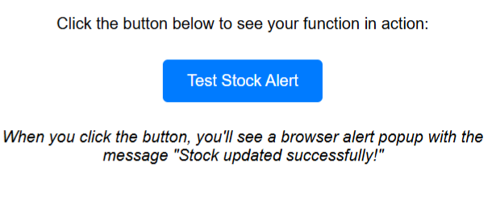
Figure 1: Sample Output for JS

for creating pages like login, dashboard, and product management.
Example (Component):
function ProductCard({ name, quantity }) {
return (
<div className="card">
<h3>{name}</h3>
<p>Quantity: {quantity}</p>
</div>
);
}

3.5 Express.js (Backend Framework)
Express is a minimal and flexible Node.js framework that simplifies backend development. It is used in this project to create RESTful APIs, handle routes, and manage middleware like authentication.
Example:
app.get("/api/products", (req, res) => {
res.send("List of products");
});

3.6 MongoDB (Database)
MongoDB is a NoSQL database that stores data in a flexible, JSON-like format. It is used here to store product details, stock history, user accounts, and audit logs. It supports scalability and fast queries, making it ideal for inventory systems.
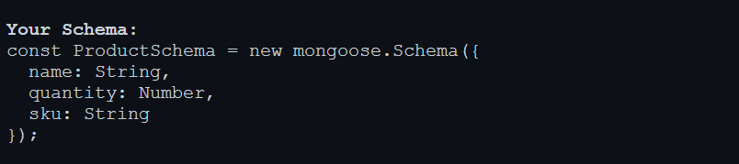
Figure 2: Sample Input for MongoDB

3.7 Git & GitHub (Version Control)
Git helps track code changes, and GitHub allows collaboration and remote storage of repositories. This project was version-controlled with Git and pushed to GitHub for backup and deployment.
Example Commands:
git init
git add .
git commit -m "Initial commit"
git push origin main

3.8 Render & Vercel (Deployment Platforms)
Render is used for deploying the backend (server + API), while Vercel is used for deploying the frontend (React app). Both platforms provide continuous deployment, so updates are live instantly after pushing to GitHub.
- Frontend URL (Vercel): https://inventory-app.vercel.app
- Backend URL (Render): https://inventory-api.onrender.com

CHAPTER 4
Client–Server Architecture

Client–server architecture is one of the most fundamental designs in computer networking and modern web applications. In this model, tasks and responsibilities are divided between the client (which requests services) and the server (which provides services). This separation allows applications to be modular, scalable, and easier to maintain.

4.1 Introduction
The client interacts with the user and sends requests, while the server processes these requests and returns responses.
For example, when you open an online shopping site, your browser (client) sends a request to the application’s server, which processes it, fetches product data from the database, and returns it as a web page.

4.2 Components of Client–Server Model
- Client
The client is typically a browser, mobile application, or desktop app. Its main job is to interact with the user, collect input, and display information. Clients are considered "thin" when they only display data, and "thick" when they also perform some processing tasks.
Example: A ReactJS-based frontend that shows product inventory details.
- Server
The server is a machine or program that stores business logic, databases, and services. It manages requests from multiple clients simultaneously and ensures correct processing of operations.
Example: A Node.js server managing login authentication and database queries.
- Database
In most systems, the server interacts with a database to store or retrieve data. This ensures persistence and consistency of data across sessions.
Example: A MongoDB database holding details of all products in an inventory system.

4.3 Client–Server Communication
The communication between client and server generally takes place over the HTTP/HTTPS protocol. The process works as follows:
- The client sends a request to the server.
- The server processes the request (sometimes consulting a database).
- The server sends back a response in a standard format like HTML, JSON, or XML.
Example:
- Request: GET /api/products
- Response:
- [
- { "id": 1, "name": "Laptop", "price": 50000 },
- { "id": 2, "name": "Phone", "price": 30000 }
- ]

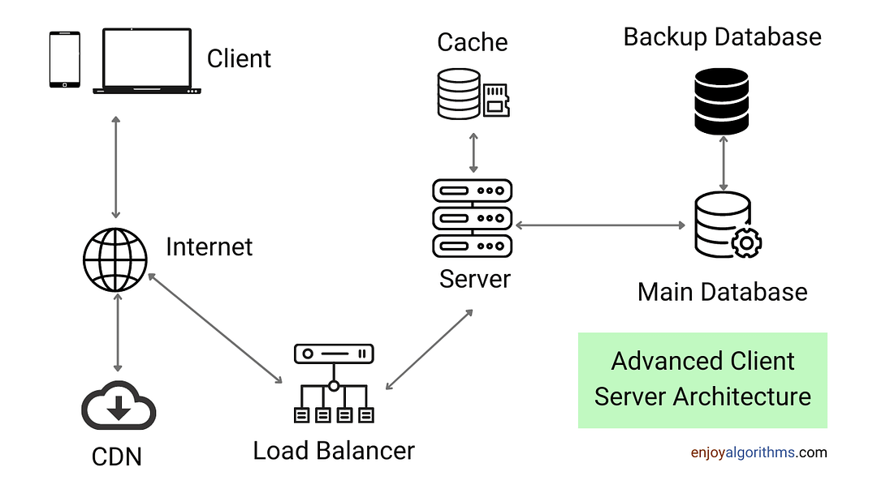
Figure 3: Client-Server Architecture

4.4 REST APIs in Client–Server Architecture
REST (Representational State Transfer) APIs are a common way for clients and servers to communicate. They use standard HTTP methods:
- GET → Retrieve data
- POST → Add new data
- PUT/PATCH → Update existing data
- DELETE → Remove data
This design makes applications modular and easy to integrate with other systems.

4.5 Advantages of Client–Server Model
- Scalability: Multiple clients can connect to a single server.
- Centralized Data: Data is stored in one place, ensuring consistency.
- Security: Servers can authenticate users before allowing access.
- Maintenance: Easier to update the server without disturbing clients.

Chapter 5
Node.js and Express

This chapter provides an overview of Node.js and Express, the core backend technologies used in Quickblog. It explains how Node.js serves as a fast, non-blocking runtime environment, while Express provides a flexible framework for building APIs. Together, they form the backbone of Quickblog’s server-side operations, managing authentication, routing, database communication, and request handling.

5.1 Introduction
Node.js and Express form the backbone of many modern web applications. While the frontend handles user interaction, it is the backend that ensures requests are processed, data is stored securely, and meaningful responses are returned. Node.js is a powerful runtime environment that allows JavaScript to be executed on the server side, while Express is a lightweight yet robust framework built on top of Node.js for building efficient web applications and APIs. Together, they provide the speed, flexibility, and scalability needed for projects such as inventory management systems.

5.2 What is Node.js?
Node.js is an open-source, cross-platform JavaScript runtime environment that runs outside of the browser. It uses the V8 JavaScript engine (developed by Google) and allows developers to write server-side applications using JavaScript.
Key Features of Node.js:
- Asynchronous and Event-Driven: Non-blocking I/O ensures multiple requests are handled simultaneously.
- Single Threaded but Highly Scalable: Uses event loops to process concurrent connections efficiently.
- Fast Execution: Built on V8 engine, making it suitable for data-intensive applications.
- NPM (Node Package Manager): Provides thousands of pre-built libraries to speed up development.
Example: In an inventory system, Node.js enables quick handling of multiple requests, such as checking stock levels, updating product details, or generating reports.
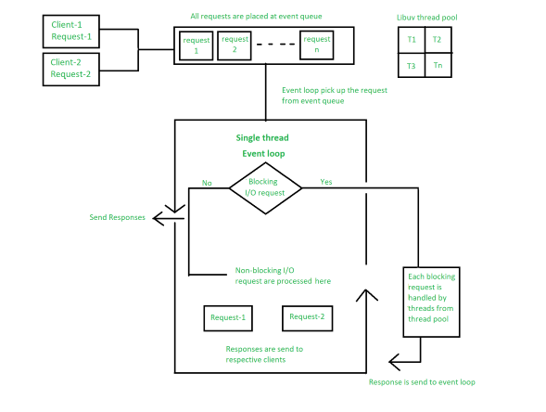
Figure 4: Node.js Architecture

5.3 What is Express.js?
Express.js is a minimal and flexible web framework for Node.js. It simplifies the process of building APIs, routing requests, and managing middleware. While Node.js provides the runtime environment, Express adds structure and essential tools to build scalable server-side applications.
Key Features of Express.js:
- Simple Routing: Define routes for handling HTTP requests (GET, POST, PUT, DELETE).
- Middleware Support: Use middleware functions to handle authentication, logging, or validation.
- RESTful API Development: Ideal for backend services that need to communicate with a frontend.
- Integration Ready: Works seamlessly with databases like MongoDB and MySQL.
Example: An Express route can be created to handle requests such as:
app.get('/inventory', (req, res) => {
res.send('Fetching all inventory items...');
});

5.4 How Node.js and Express Work Together
In a typical application:
- The client sends an HTTP request (e.g., fetch all products).
- The Node.js server with Express receives and processes the request.
- If data is needed, Express communicates with the database.
- The server sends a response (e.g., product list, stock count) back to the client.
This request-response cycle ensures smooth communication between the frontend and backend.

5.5 Example in Inventory Management System
- Adding Products: A POST API in Express receives product data and stores it in MongoDB.
- Updating Quantity: A PUT API modifies stock levels when items are added or sold.
- Generating Reports: A GET API fetches inventory reports for analysis.
- Authentication: Middleware ensures only authorized users can modify stock details.
Sample Code:
const express = require('express');
const app = express();
app.use(express.json());
// Example route
app.post('/add-product', (req, res) => {
const product = req.body;
// Save product to database (logic skipped here)
res.send(`Product ${product.name} added successfully!`);
});
app.listen(5000, () => {
console.log('Server running on port 5000');
});

5.6 Advantages in Real-World Applications
- Scalability: Node.js can handle thousands of simultaneous connections.
- Speed: Express provides a minimalistic structure that avoids overhead.
- Cross-Platform Development: Works on Windows, macOS, and Linux.
- Community Support: Large ecosystem of libraries and modules.
For your inventory project, this ensures faster request handling, secure APIs, and smooth integration with frontend technologies like ReactJS.

CHAPTER-6

PROJECT DESCRIPTION

The Inventory Management System is a full-stack web application developed with the aim of optimizing and digitalizing warehouse and inventory management operations. In many organizations, inventory management still relies on manual record-keeping, spreadsheets, or outdated software, which often leads to inefficiencies such as mismatched stock levels, delayed reporting, lack of accountability, and difficulty in scaling. This project addresses these challenges by offering a centralized, cloud-hosted solution that combines real-time data tracking, secure access, and automated reporting features. It provides organizations with complete visibility into stock inflows, outflows, and balances, allowing managers to make data-driven decisions and maintain efficiency across the supply chain.

Built on the MERN stack (MongoDB, Express.js, React, Node.js), the system leverages the strengths of modern web technologies to provide a scalable and user-friendly platform. The frontend, developed in React.js, serves as the interface between users and the system. It offers a responsive and interactive design where administrators and staff can manage daily operations with ease. React’s component-based architecture ensures modularity, meaning individual features such as forms, tables, and dashboards can be developed and maintained independently. The user experience is further enhanced with real-time updates, responsive layouts, and consistent UI styling across all modules.

The frontend is designed around key modules: Inset (Inbound), Outset (Outbound), Inventory Overview, Audit Logs, and Administrative Controls. Users can add new stock entries, dispatch items, monitor available quantities, and generate reports without switching between multiple systems. For smooth interaction, reusable components such as dropdowns, modals, and validation-enabled forms have been implemented. For example, while recording inbound stock, a modal form allows users to quickly add product details, batch numbers, quantities, and timestamps. The data is validated at both client and server levels to ensure accuracy before storage.

Security is a core focus of the application. The system uses JWT (JSON Web Token) authentication to secure routes, ensuring only authenticated users can access sensitive features. On top of authentication, role-based access control has been integrated, meaning administrators, managers, and staff have different levels of access. For example, staff may only update quantities, while administrators can create or delete user accounts. This layered security approach not only prevents unauthorized access but also ensures accountability by clearly defining responsibilities within the system.

The backend, built with Node.js and Express.js, acts as the middleware connecting the frontend to the database. It follows a structured MVC (Model-View-Controller) architecture, ensuring separation of concerns and easier maintainability. Models define MongoDB schemas for entities such as products, users, and transactions. Controllers handle business logic, such as creating new inventory records, updating stock after outbound transactions, or generating downloadable reports. Routes define RESTful API endpoints that the frontend communicates with. Middleware ensures smooth functioning by managing authentication, error handling, and request validation. One critical middleware component is the audit logging system, which automatically records every transaction or modification. For example, if a user updates the quantity of a product, the system logs the user ID, timestamp, and action details. This provides a complete history of changes, making the system transparent and trustworthy.

At the data layer, MongoDB provides the flexibility and scalability required to manage inventory data. Unlike relational databases, MongoDB’s schema-less nature supports dynamic structures, allowing easy management of varying product details such as SKUs, batch IDs, pack sizes, or expiration dates. This is particularly valuable for organizations handling diverse inventory types, where some products may require additional attributes while others do not. Queries are optimized to quickly fetch stock details, generate low-stock alerts, and retrieve historical records for reporting purposes.

One of the most notable features of this project is the integration of Excel file import using Multer and XLSX libraries. Many organizations still use Excel spreadsheets to maintain bulk product lists, vendor details, or purchase records. Manually entering thousands of records into a new system can be time-consuming and error-prone. To solve this, the system allows users to upload Excel files directly through the application. The backend processes these files using Multer (for file handling) and XLSX (for parsing Excel data). Once uploaded, the system validates the entries, checks for duplicates, and inserts the data into MongoDB collections. This feature dramatically reduces the time required for data migration and ensures seamless integration with existing workflows. For instance, when onboarding a new warehouse with 10,000 products, administrators can simply prepare a master Excel file and upload it within minutes. This reduces human effort and eliminates the errors common in manual data entry.

The system also supports report generation and data export, allowing managers to download filtered reports in Excel or CSV format for offline analysis. For example, an admin may choose to generate a monthly outbound report showing which items were dispatched, in what quantity, and by whom. These reports can be used for financial reconciliation, supplier negotiations, or compliance audits.

Deployment of the system follows a cloud-first strategy, where the frontend is deployed on Vercel and the backend on Render, with MongoDB hosted through MongoDB Atlas or Render’s managed database service. This ensures scalability, high uptime, and global accessibility. Vercel provides a globally distributed CDN, making the frontend fast to load across regions, while Render manages backend scaling and secure API hosting. Secure communication between the two is established using environment variables and protected API endpoints. This architecture makes the system production-ready and capable of supporting multiple warehouses or branches simultaneously.

From a usability perspective, the system is designed with a professional and clean interface that maintains consistency across all modules. Tables in inbound, outbound, and inventory modules follow the same style, making it easier for users to adapt without a steep learning curve. Search and filtering options make it simple to handle large datasets, while responsive design ensures accessibility on desktops, tablets, and smartphones alike. This flexibility is particularly important for managers who may need to check stock levels or approve transactions while on the move.

The broader impact of the Inventory Management System lies in how it transforms traditional warehouse management practices. By offering a single source of truth, it eliminates discrepancies caused by fragmented records or uncoordinated tools. By supporting audit logs, it enhances accountability; by offering low-stock alerts, it improves replenishment planning; by integrating Excel import, it bridges the gap between legacy workflows and modern applications. Collectively, these features create a solution that not only digitizes inventory management but also prepares organizations for future growth, automation, and integration with technologies like IoT or AI-driven demand forecasting.

CHAPTER-7
Screenshots of Output

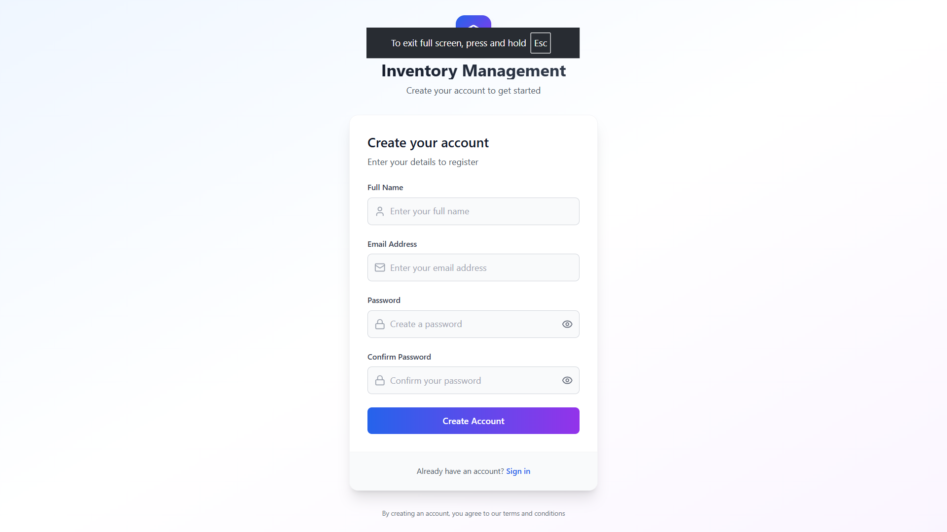
Figure 5.1: Registration Page

Displays the user registration form for creating new accounts. Ensures secure onboarding with required user details.

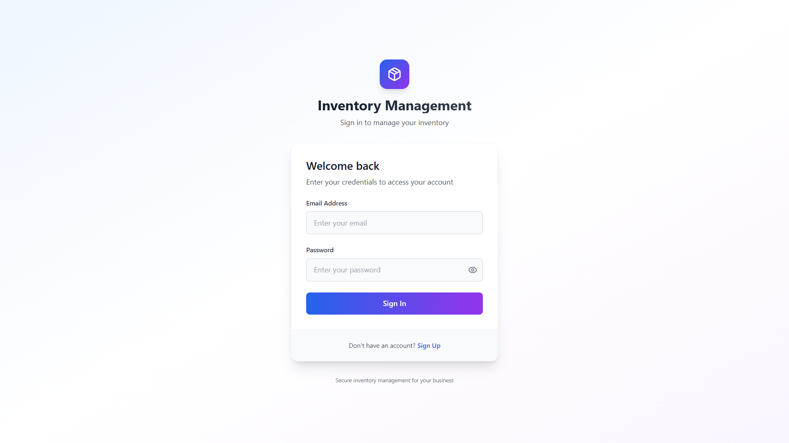
Figure 5.2: Login Page

Provides authenticated access to the system through email and password. Prevents unauthorized entry into the inventory platform.

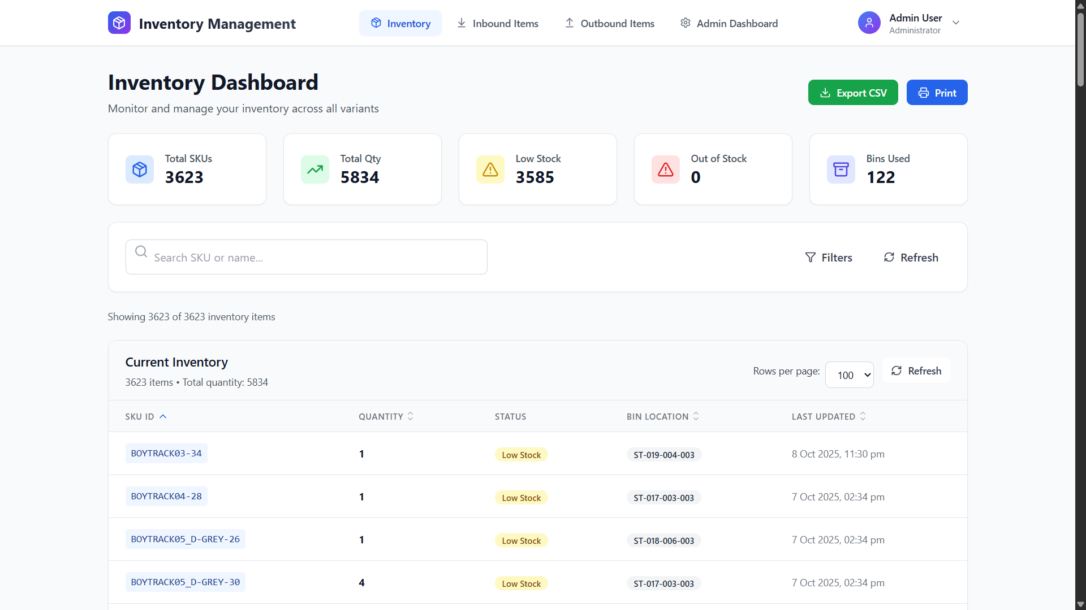
Figure 5.3: Inventory Dashboard

Shows an overview of key inventory metrics like stock, inbound, and outbound. Acts as the central hub for navigating system features.
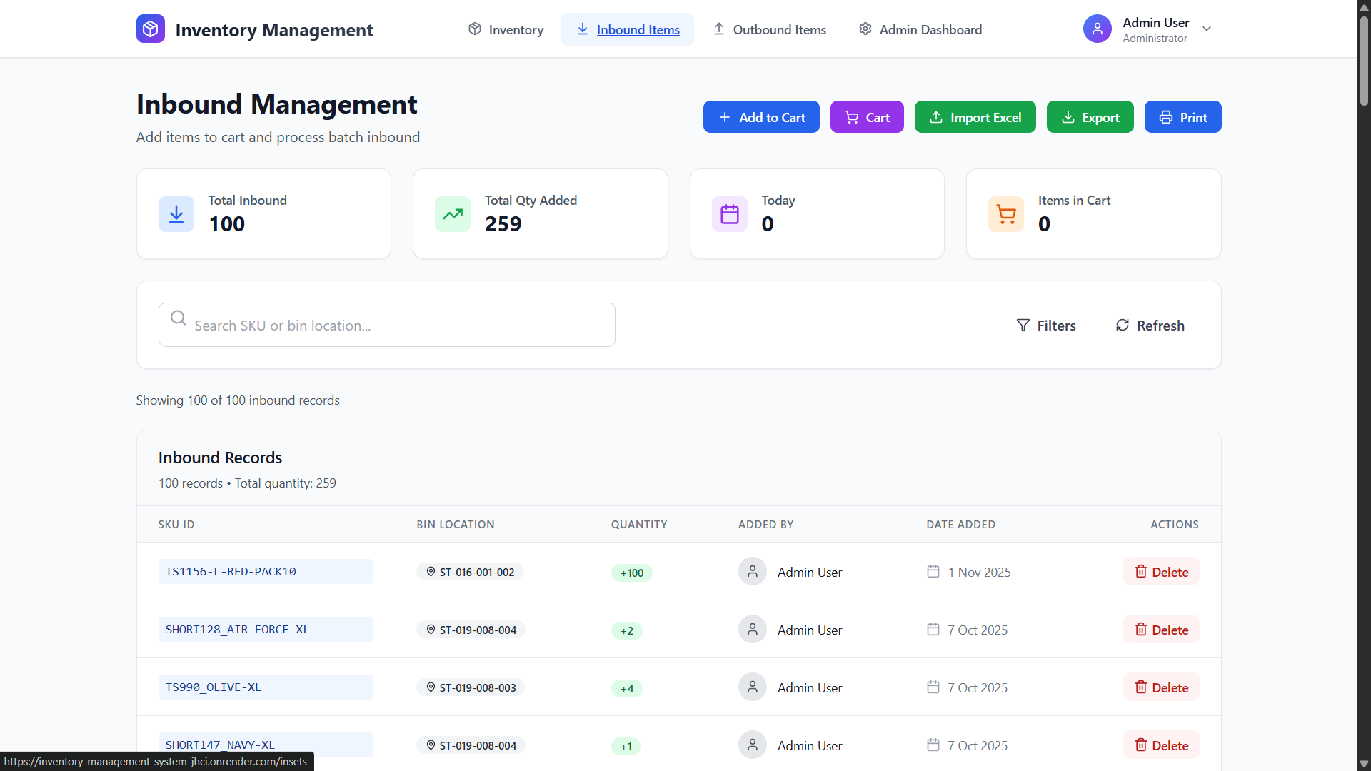
Figure 5.4: Inbound Items Dashboard

Displays inbound stock records with search, filter, and import options. Allows admins to add, track, and manage new inventory entries.

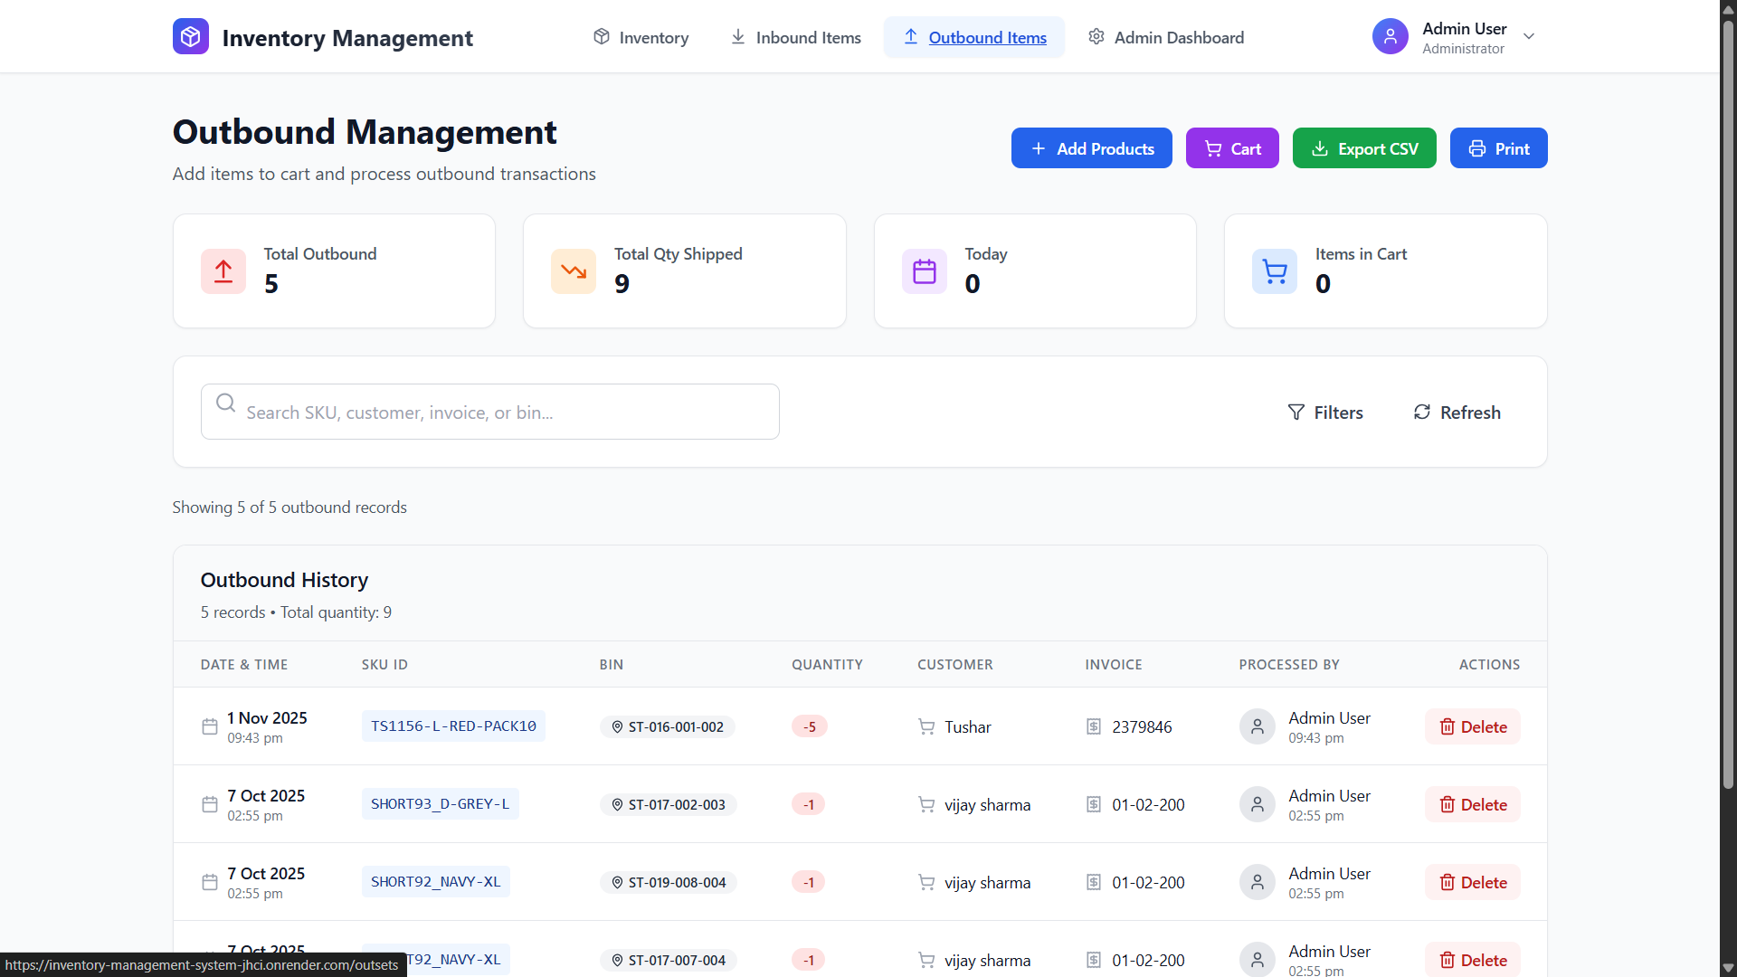
Figure 5.5 Outbound Items Dashboard

Shows all outbound item records with shipping, customer, and invoice data. Helps track items leaving the warehouse in real time.

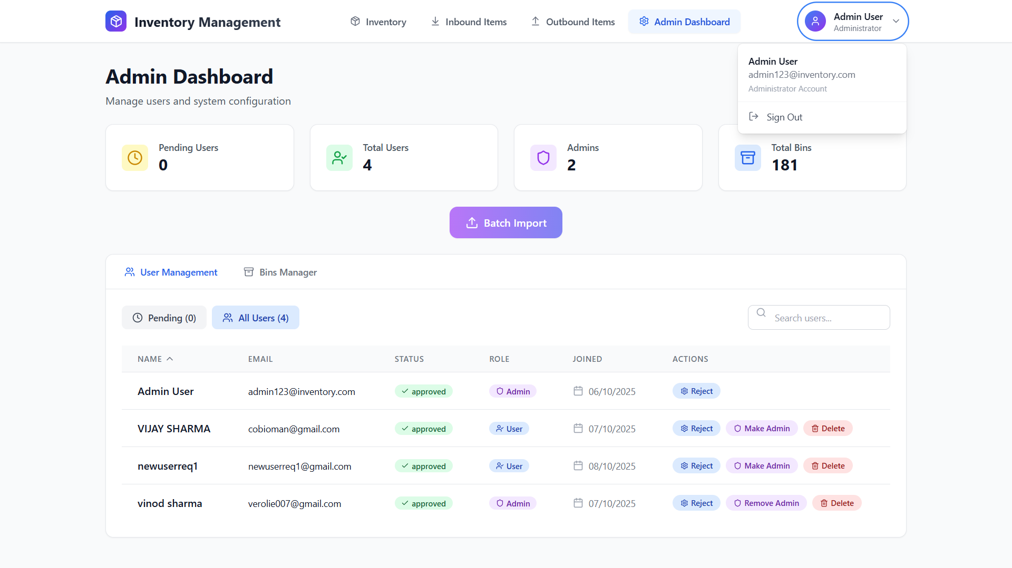
Figure 5.6: Admin Dashboard

Provides an overview of admin-specific controls and monitoring features. Enables user management and overall system supervision.
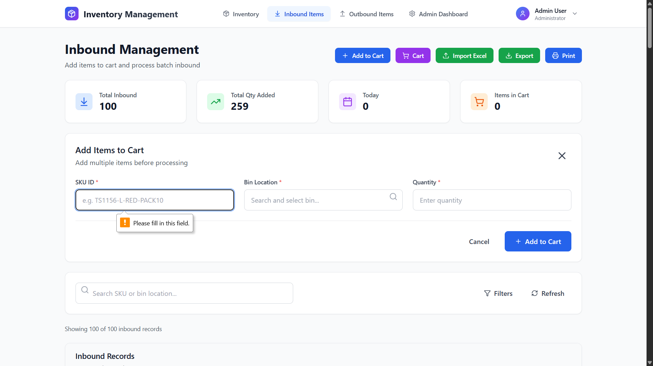
Figure 5.7: New inbound by Add to Cart Option

Allows adding items into an inbound cart before final submission. Simplifies bulk inbound entry with user-friendly cart flow.

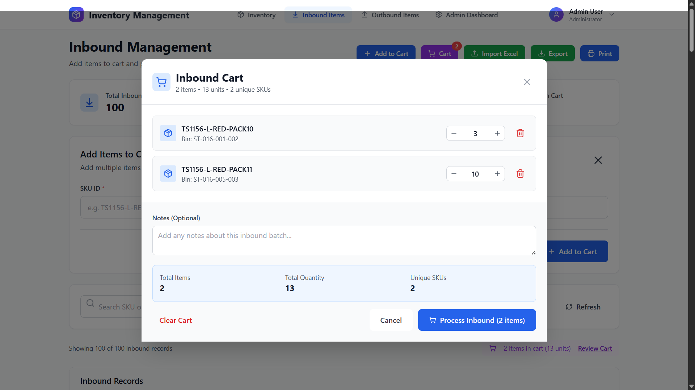
Figure 5.8: Inbound Cart

Shows the list of inbound items prepared for batch processing. Lets admins review and finalize the records before adding them.

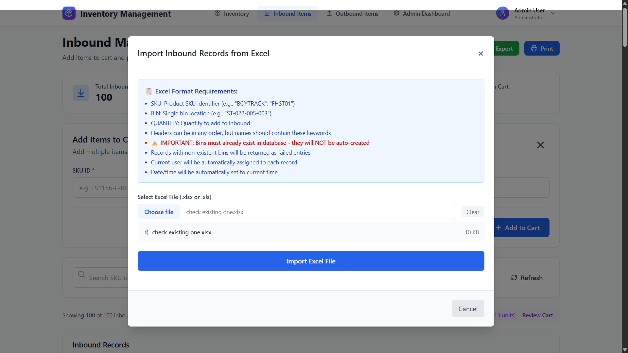
Figure 5.9: Batch Import Feature

Supports uploading Excel files to add multiple inbound items at once. Speeds up large-scale inventory updates using automation.

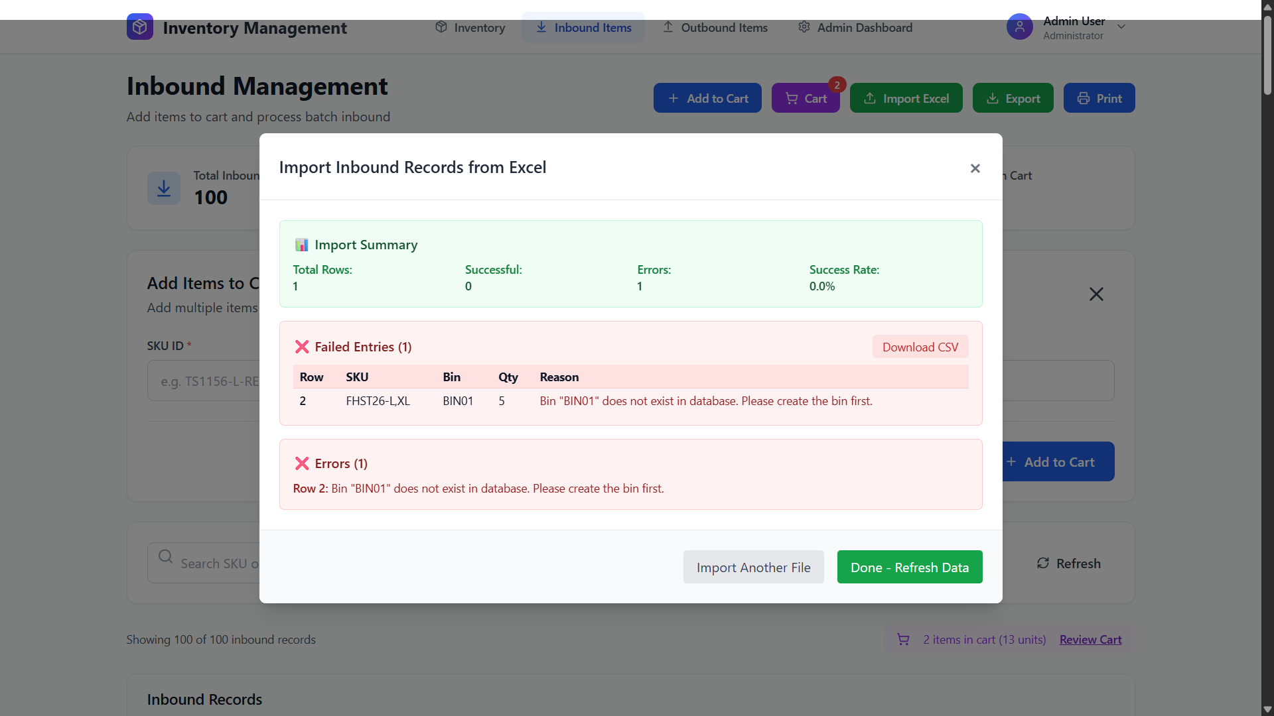
Figure 5.9: Errors and wrong inputs handling

Displays system alerts and messages for incorrect or missing inputs. Ensures data accuracy by preventing invalid submissions.

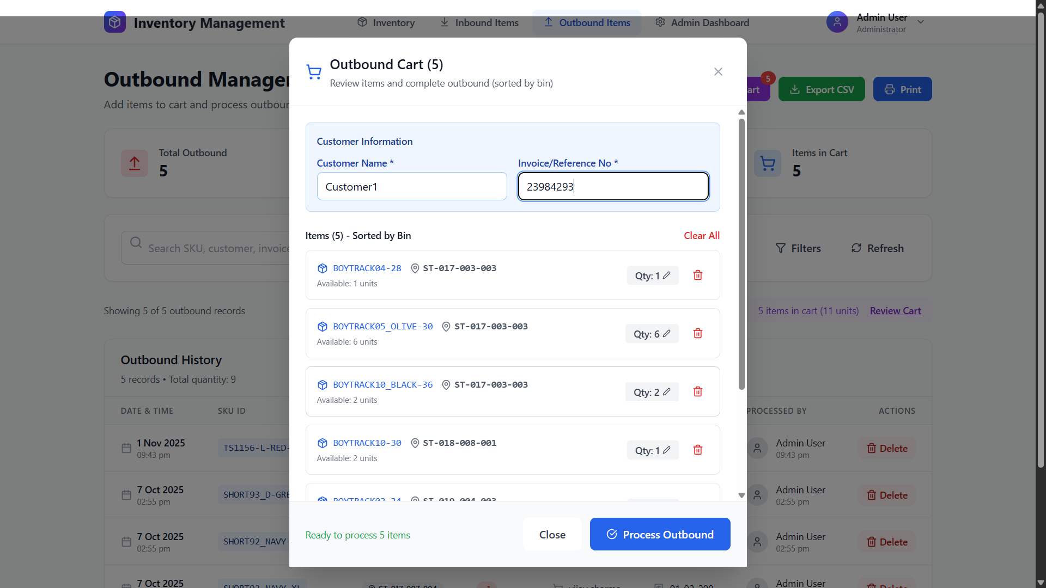
Figure 5.10: Outbound Cart

Lists outbound items selected for dispatch in a cart-style interface. Helps verify quantities and details before shipping.

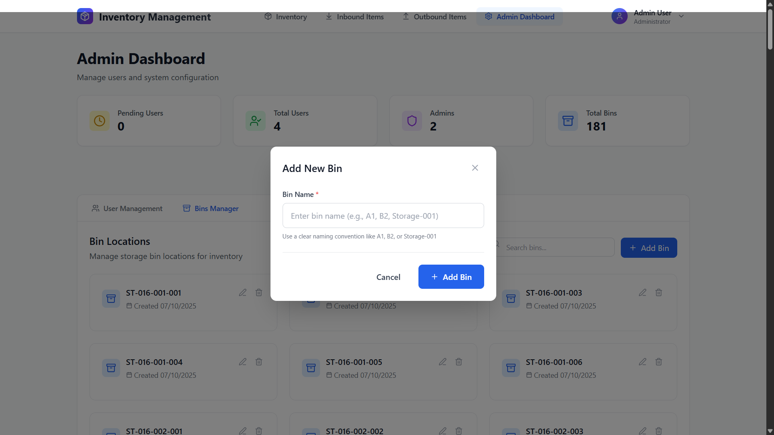
Figure 5.11: Add Bins

Enables creation of new bin locations for organizing inventory. Improves warehouse structure by assigning items to bins.

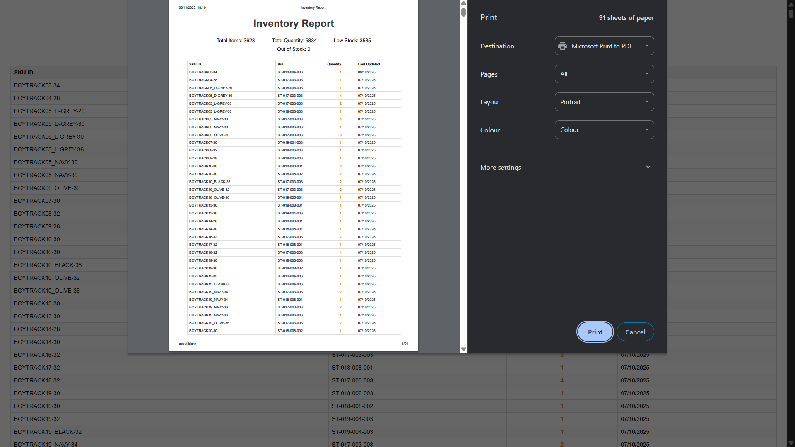
Figure 5.12: Print to pdf feature

Generates printable PDF reports of inventory activity. Helps maintain documentation and share transaction summaries easily.

CONCLUSION

Building this Inventory Management System has clearly highlighted the importance of using the right technologies and development practices. By adopting the MERN stack (MongoDB, Express, React, Node.js), the project became more reliable, scalable, and easy to maintain. The use of standard tools like JWT authentication, audit logs, and role-based access ensured that the application stayed secure and user-friendly.
Just as a well-designed website built with standard resources works across all browsers, this system operates smoothly across different platforms and environments because it follows best development practices. The deployment on Render for the backend and Vercel for the frontend further improved accessibility, making the application available anytime with minimal downtime.
The modular code structure of the project ensured that each component—authentication, inventory operations, report generation, and notifications—was independent yet seamlessly integrated. This makes the system easier to update, troubleshoot, and expand with new features in the future.
The system also replaces traditional manual stock handling with a more automated, fast, and accurate process. Features like real-time stock updates, alerts for low inventory, batch SKU management, and report downloads provide clear visibility to users and significantly reduce the chances of errors.
Another key takeaway is that the project demonstrates how technology can simplify everyday business challenges. Instead of relying on paperwork and guesswork, organizations can now rely on a transparent, centralized solution for managing their inventory.
In the end, this project highlights how the right combination of tools and practices can result in a system that is simple, secure, efficient, and valuable to organizations of all sizes. It not only meets the requirements of today but also lays a strong foundation for future enhancements and scalability.

FUTURE SCOPE

The Inventory Management System has been built to be scalable, leaving room for several future enhancements. One promising direction is the integration of AI-driven analytics that can forecast demand, identify trends, and recommend optimal stock levels, reducing both shortages and overstocking.
Another potential upgrade is IoT integration, where smart sensors, RFID tags, and barcode scanners automatically update stock levels in real time, reducing manual work and errors. Similarly, expanding to multi-location management will help businesses monitor inventory across multiple warehouses, with options to transfer stock seamlessly.
A dedicated mobile application could also be introduced, making it easier for managers and staff to track, update, and approve stock changes on the go. Features like push notifications for low stock or pending approvals would improve efficiency.
From a security perspective, future versions can adopt multi-factor authentication, advanced role-based controls, and compliance standards like GDPR, making the system suitable for larger enterprises.
The system could also be enhanced by integrating with third-party platforms such as e-commerce portals, payment gateways, and accounting tools, turning it into a complete business solution. Additionally, moving towards cloud-native deployment with Docker or Kubernetes would make scaling easier and ensure high availability.
In short, the project can evolve from a simple inventory tracker into a comprehensive business operations platform, capable of handling analytics, automation, security, and integrations as organizational needs grow.

REFERENCES

1. Research Papers
[1] Mithun Satheesh, Full-Stack Web Development with MongoDB and Node.js.
[2] P. Crichton, The Rational Unified Process, Reading, Mass., 1999.
[3] Anuj Adhikari, Full Stack JavaScript: Web Application Development with MERN.
2. Other Sources
[1] “Website Development,” TutorialsPoint. Available at: https://www.tutorialspoint.com/internet_technologies/websites_development.htm
[2] “Begin Web Development with a Head Start,” GeeksforGeeks. Available at: https://www.geeksforgeeks.org/begin-web-development-with-a-head-start/
[3] “Resources for Getting Started with Web Development,” Stack Overflow. Available at: https://stackoverflow.com/questions/12669/resources-for-getting-started-with-
[4] RisingStack. Available at: https://risingstack.com/
3. AI Tool
[1] Perplexity AI, used as a supplementary source for explanations and clarifications.

